Grammer mistakes of using alphabets ,uk and american english.

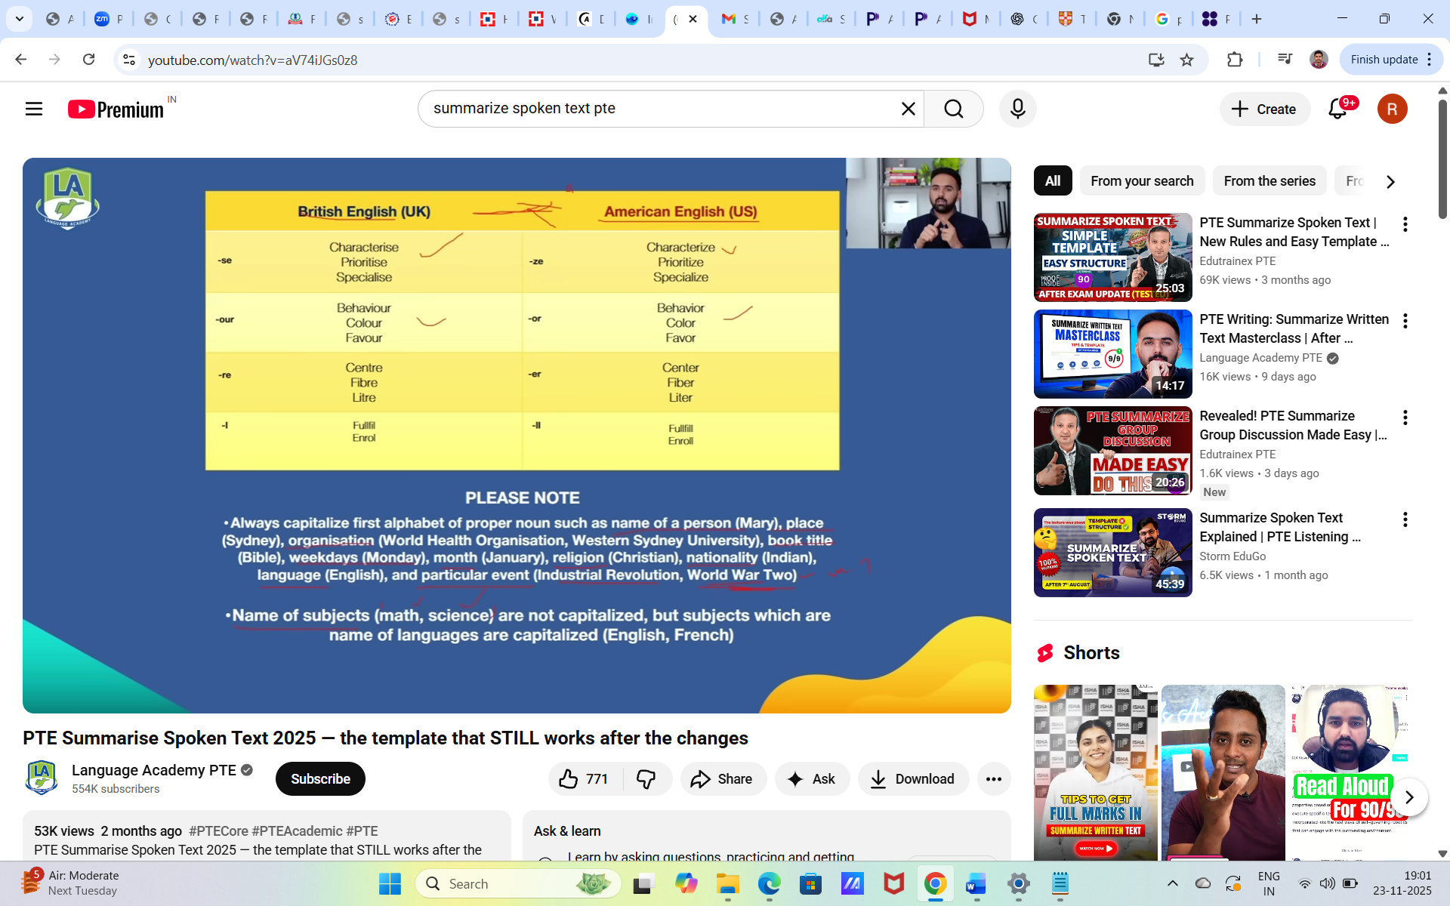

**Speaking**

<https://youtu.be/11JrDH9pa1o?si=uxN1dgKMwkYi3H2q>

**Self Intro:**

Hi, I am Rajesh, I am from Bangalore, India.

I have completed my bachelor’s in Electronics and communication Engineering.

I have 7 years of experience working as a Software engineer.

I’m taking PTE exam to migrate.

**Read aloud:**

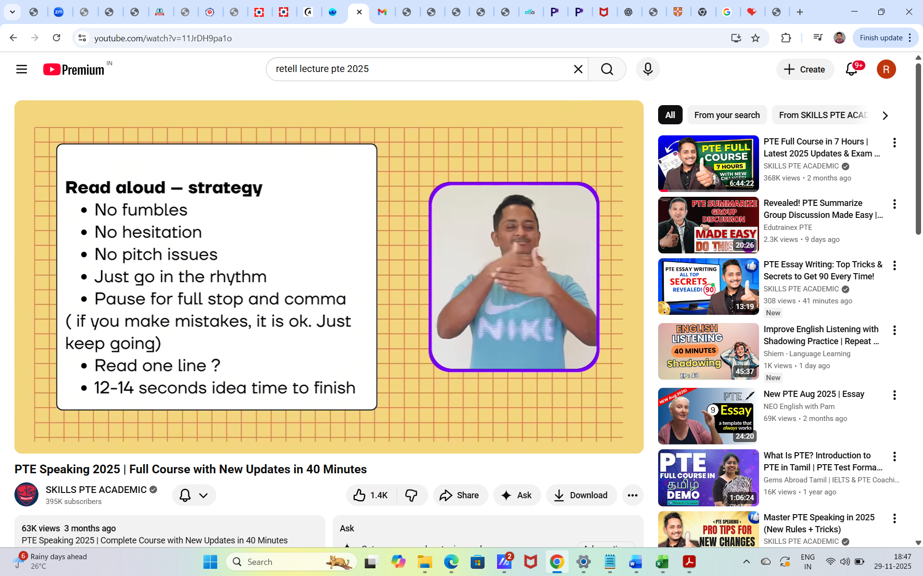

**Repeat sentence:**

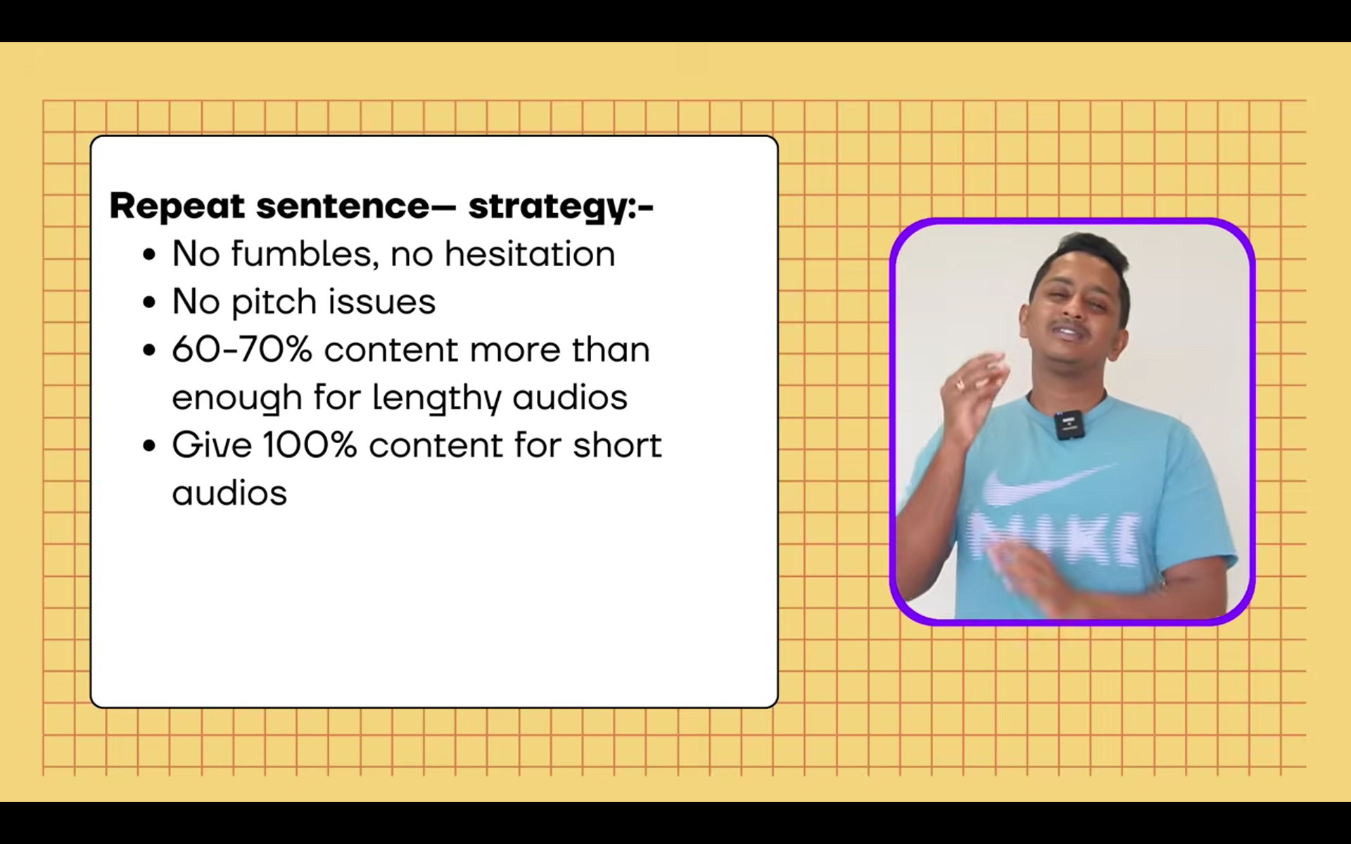

**Describe image:**

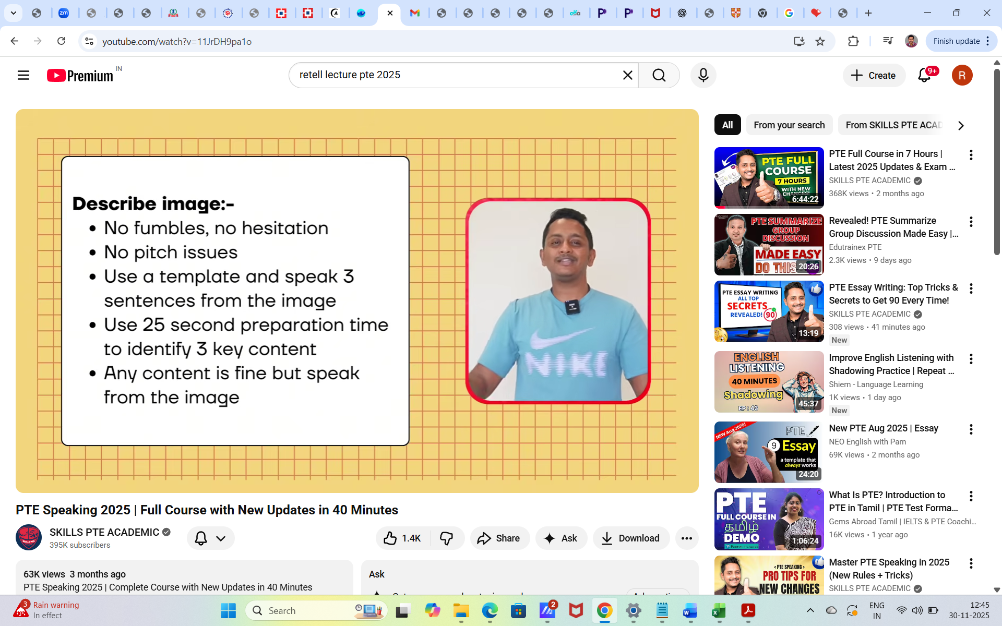

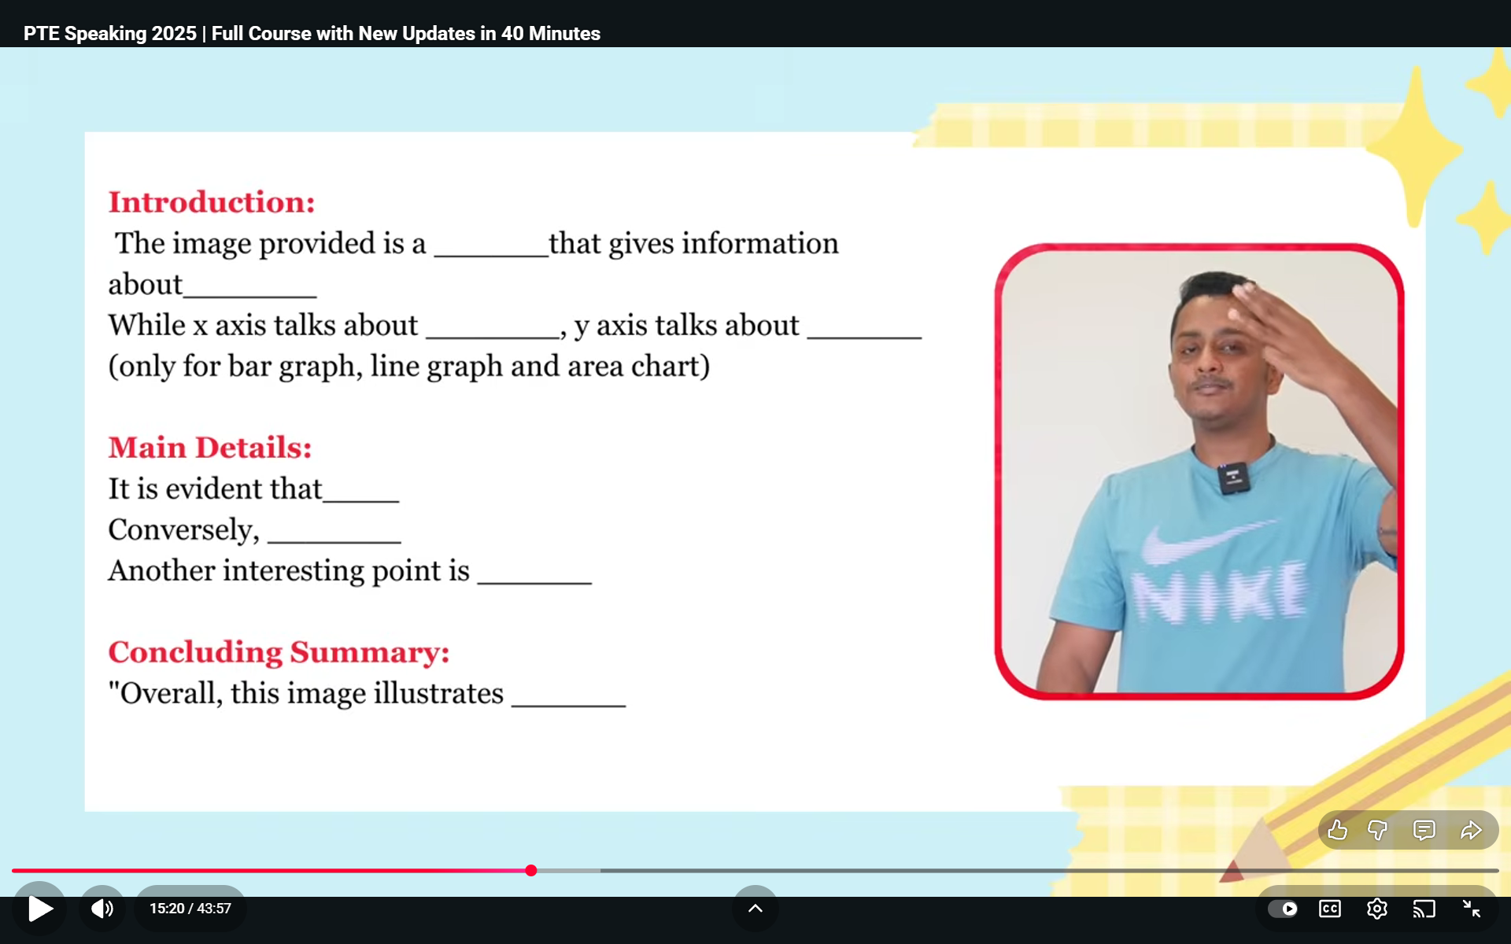

**No grammar issues in describe image**

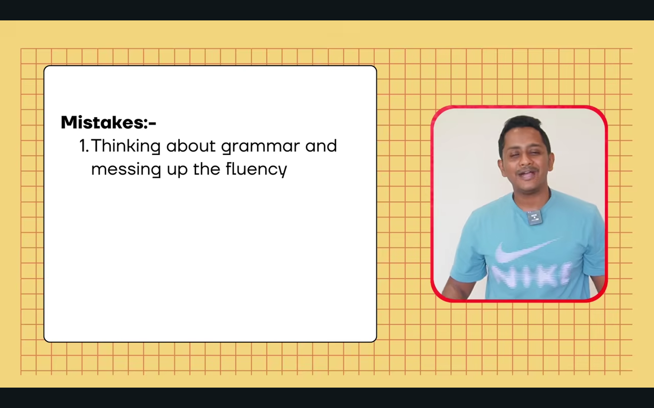

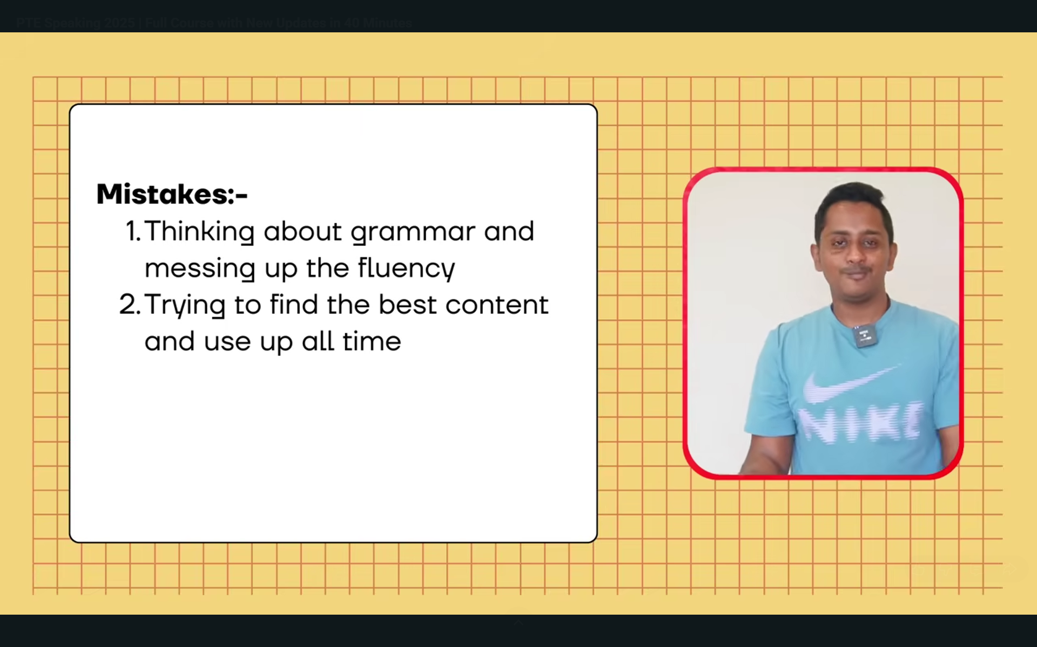

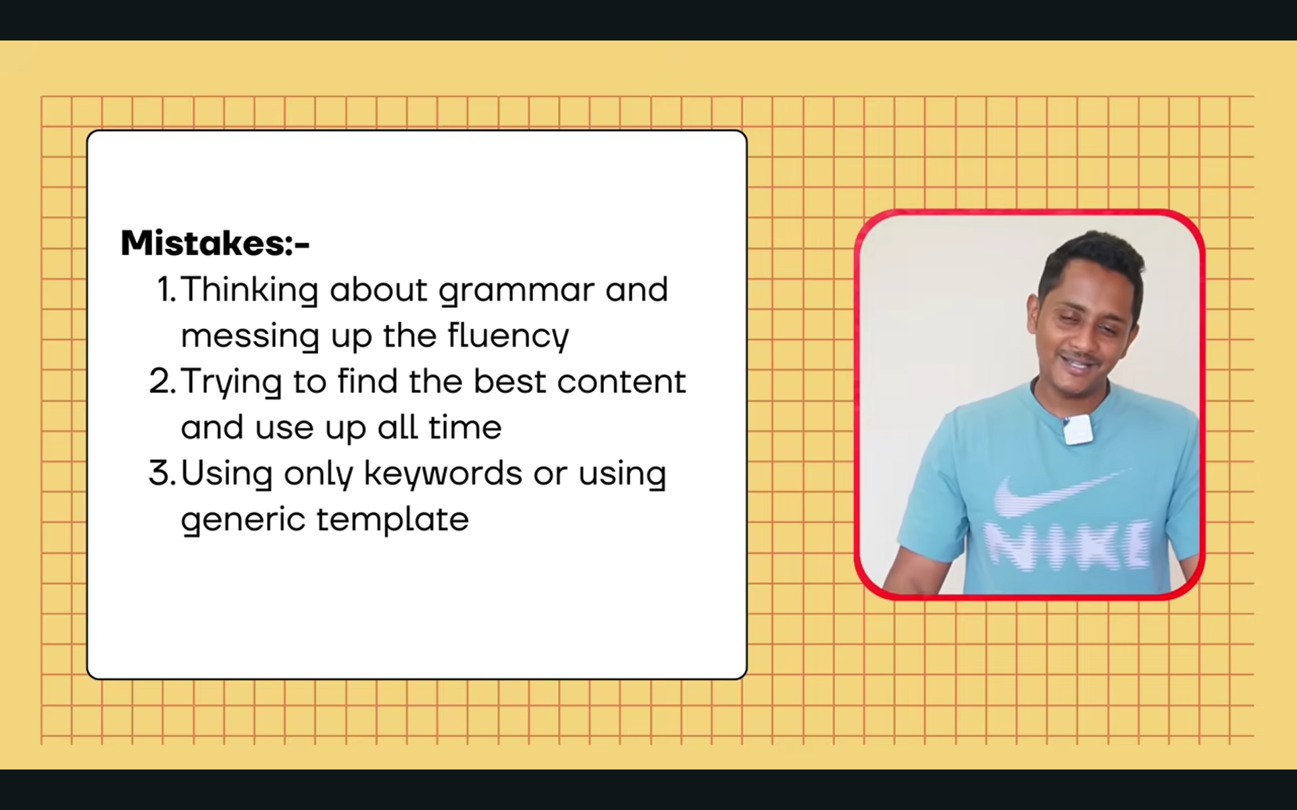

**Retail lecture:**

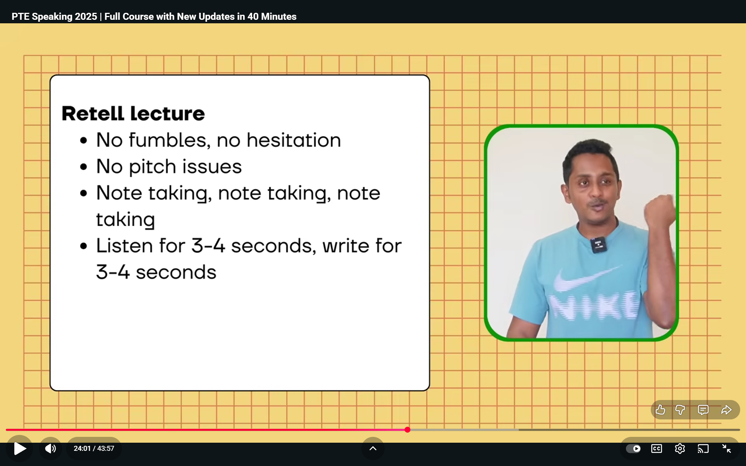

**Template:**

The lecture mainly talked about...... In the beginning, the speaker said that....... Later speaker explained that .... Furthermore, the speaker stated that

Same no grammar issue here

Practice shadow speaking for 10 mins like play an audio and practice

Listen 4 to 5 secs and write down that in next few seconds and meanwhile writing do not listen audio.

Try to write 4 to 5 phrases.

If you are well in retell lecture, easy to do group discussion:

**Respond to a situation:**

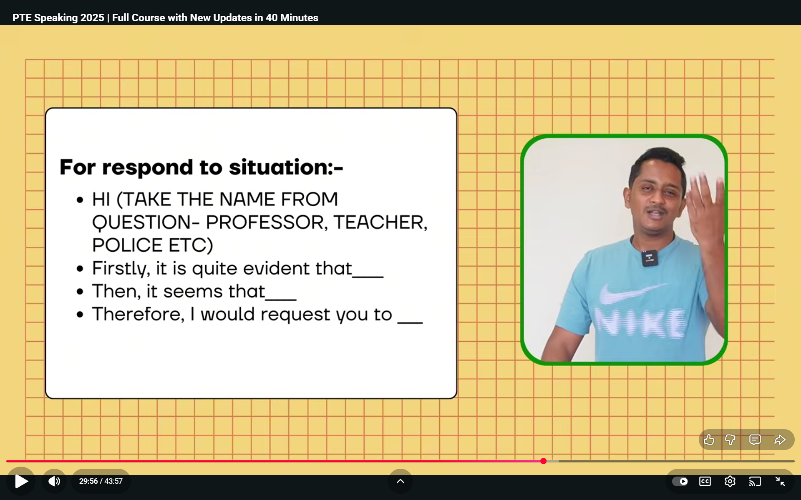

Use the beginning time and audio time and prepation time

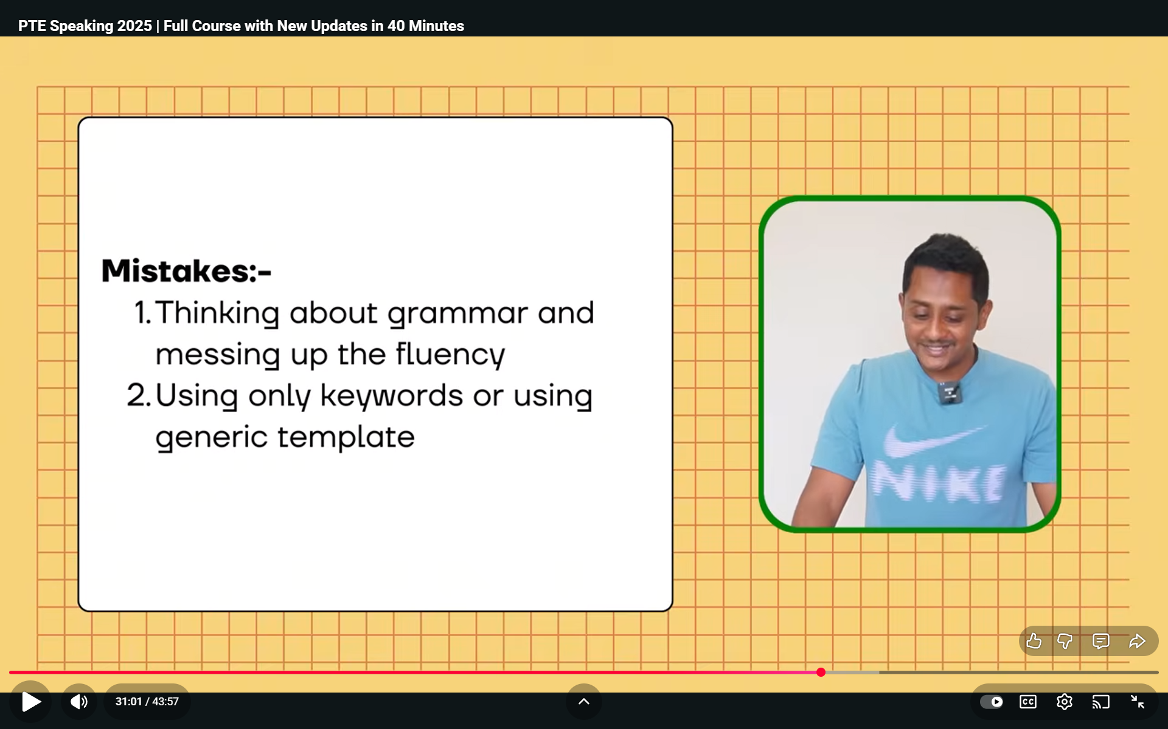

**Summarise group discussion:**

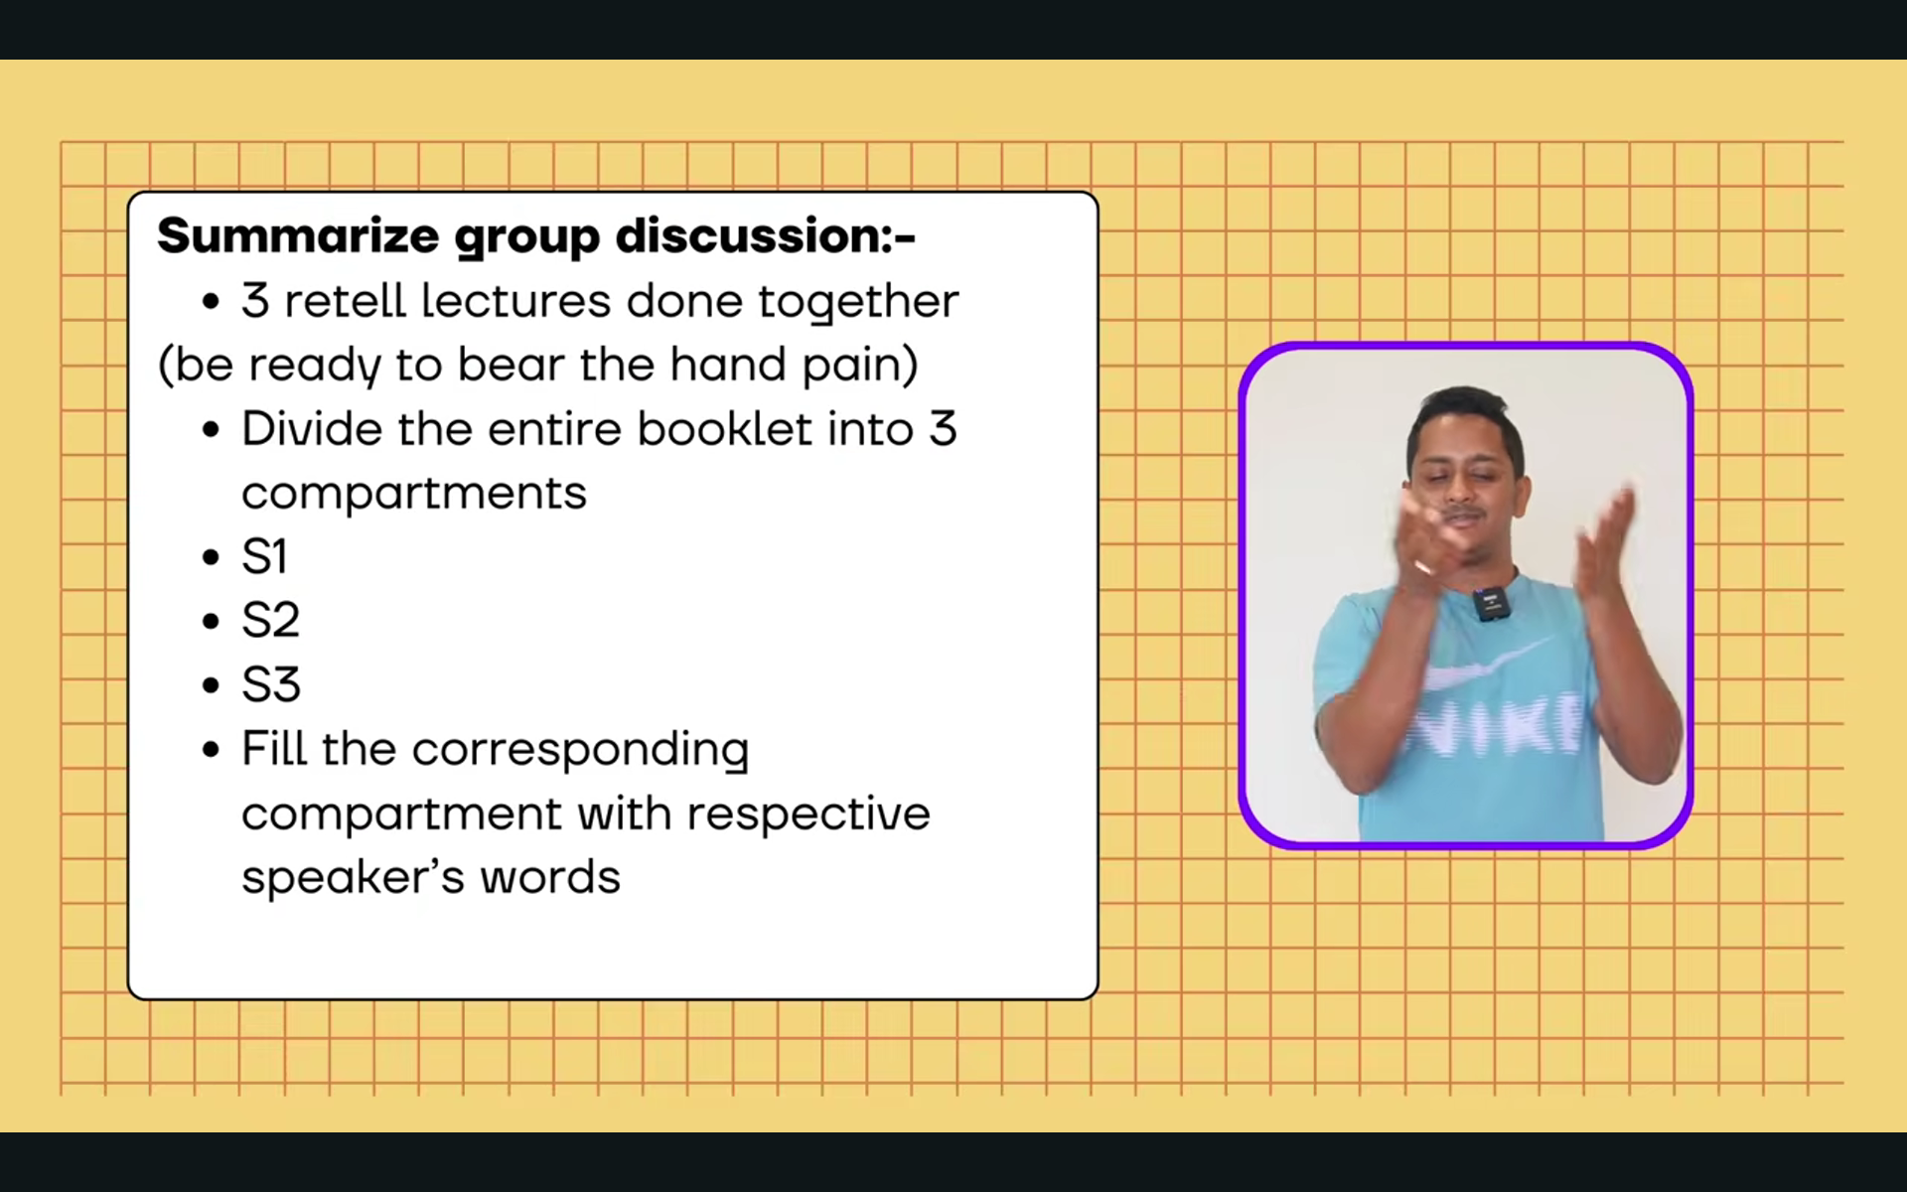

You have to speak 1 to 1.20 sec

Divide three section like this:

After note taking, try to speak what speaker 1 spoke completely and then move on to 2 nd speaker said.

**Template:**

The discussion was about heading, and three speakers were involved in the discussion. In the beginning, the first speaker said that, ….

The speaker also mentioned that ….

Furthermore, the speaker stated that ….

